CSE 3002 – INTERNET AND WEB PROGRAMMING
DHRUBANKA DUTTA – 17BCE1019
L – 43,44
PHP COOKIES AND SESSIONS
FACULTY : DR. SANDHYA P

Q1:
Implement the following cookies using PHP

Create a cookie with a value IWP.
The cookie should expire in 3 days
Check whether the cookie is present in the website. If so display else through an error
Check whether the cookie is enabled or not. Print the status
Delete the created cookie before an hour
Check whether the cookie is disabled or not. Print the status

CODE:

<!DOCTYPE html>
<?php

//==================
//FUNCTIONS
//==================
function createCookie($cookie_name, $cookie_value, $expire_time) {

setcookie($cookie_name, $cookie_value, $expire_time,"/"); //86400 = 24*60*60
echo "Cookie created with name: ".$cookie_name."<br>";
echo "Cookie created with value: ".$cookie_value."<br>";
echo "Cookie created with expiry time: ".$expire_time."<br>";
}

function check_enabled() {

if(count($_COOKIE) > 0) {
echo "Cookies are enabled.<br>";
} else {
echo "Cookies are disabled.<br>";
}

}
function check_present($cookie_name) {

if(!isset($_COOKIE[$cookie_name])) {
echo "Error: Cookie is not present<br>";
} else {
echo "Cookies is present<br>";
echo "Cookie '".$cookie_name."' is set!<br>";
echo "Value is: ".$_COOKIE[$cookie_name]."<br>";
}

}

function destroy($cookie_name) {

setcookie($cookie_name,"",time()-3600); // set cookie expiry time to an hour ago

}

//======
//MAIN
//======

$cookie_name = "test";
$cookie_value = "IWP";
$expire_time = time()+86400*3;

createCookie($cookie_name, $cookie_value, $expire_time);
echo "<br>";

check_present($cookie_name);
echo "<br>";

check_enabled();
echo "<br>";

destroy($cookie_name);
echo "<br>";

check_enabled();
echo "<br>";

check_present($cookie_name);
?>

OUTPUT:

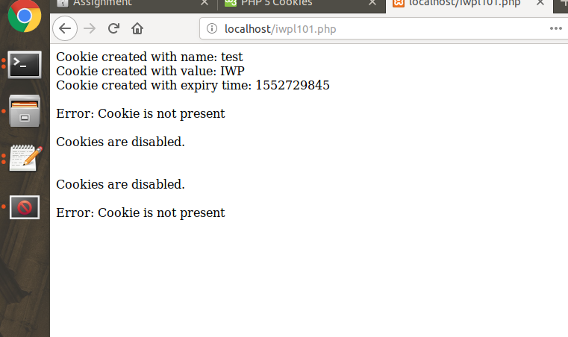

Q2:
Assume that you are registering courses in your FFCS login. Enter your username and password. If the credentials are authenticated, start a session and display a catalogue page which displays the available courses and its credits for a semester with checkboxes for each course for selection. Perform the following:
-> Check the courses you want to register and register them by clicking a submit button.
-> The total number of credits for the selected courses should be less than or equal to 27.
-> If so, display all the selected courses and the total in a separate page which should have a link for sign-out during which the session will be terminated.

CODE :

iwpl102.html

<!DOCTYPE html>
<html>
<head>
<title>LOGIN TO FFCS</title>
</head>
<body>

<h2>Login Form</h2>

<form action="iwpl102.php" method="post">
Enter Username <br><br>
<input type="text" name="uname" value="Username"><br><br><br><br>
Enter Password <br><br>
<input type="password" name="pass" value="Password"><br><br>
<input type="submit" name="submit">

</form>

</body>
</html>

iwpl102.php

<?php
session_start();
if(isset($_POST['submit']) && $_POST[‘uname’]==’usename’ && $_POST[‘pass’]==’password’) {

echo "
<!DOCTYPE html>
<html>
<body>
<form action='iwpl102_eval.php' method='post'>
<h3>COURSE - CREDITS</h3>
<input type = 'checkbox' name='check1'> Course 1 - 1 credit<br><br>
<input type = 'checkbox' name='check2'> Course 2 - 1 credits<br><br>
<input type = 'checkbox' name='check3'> Course 3 - 1 credits<br><br>
<input type = 'checkbox' name='check4'> Course 4 - 1 credits<br><br>
<input type = 'checkbox' name='check5'> Course 5 - 2 credits<br><br>
<input type = 'checkbox' name='check6'> Course 6 - 2 credits<br><br>
<input type = 'checkbox' name='check7'> Course 7 - 2 credits<br><br>
<input type = 'checkbox' name='check8'> Course 8 - 2 credits<br><br>
<input type = 'checkbox' name='check9'> Course 9 - 3 credits<br><br>
<input type = 'checkbox' name='check10'> Course 10 - 3 credits<br><br>
<input type = 'checkbox' name='check11'> Course 11 - 3 credits<br><br>
<input type = 'checkbox' name='check12'> Course 12 - 3 credits<br><br>
<input type = 'checkbox' name='check13'> Course 13 - 4 credits<br><br>
<input type = 'checkbox' name='check14'> Course 14 - 4 credits<br><br>
<input type = 'checkbox' name='check15'> Course 15 - 4 credits<br><br>
<input type = 'checkbox' name='check16'> Course 16 - 4 credits<br><br>
<input type = 'submit' value = 'Finalise Selection' name='submit_final'>
";
} else {
session_destroy();
// Display the Form and the Submit Button
echo "did not get form values";
}

?>

iwpl102_eval.php

<?php

if(isset($_POST['submit_final'])) {
// Enter the code you want to execute after the form has been submitted
// Display Success or Failure message (if any)
$sum = 0;
echo "got form values<br>";
if(isset($_POST['check1'])) {$sum = $sum+1;};
if(isset($_POST['check2'])) {$sum = $sum+1;};
if(isset($_POST['check3'])) {$sum = $sum+1;};
if(isset($_POST['check4'])) {$sum = $sum+1;};
if(isset($_POST['check5'])) {$sum = $sum+2;};
if(isset($_POST['check6'])) {$sum = $sum+2;};
if(isset($_POST['check7'])) {$sum = $sum+2;};
if(isset($_POST['check8'])) {$sum = $sum+2;};
if(isset($_POST['check9'])) {$sum = $sum+3;};
if(isset($_POST['check10'])) {$sum = $sum+3;};
if(isset($_POST['check11'])) {$sum = $sum+3;};
if(isset($_POST['check12'])) {$sum = $sum+3;};
if(isset($_POST['check13'])) {$sum = $sum+4;};
if(isset($_POST['check14'])) {$sum = $sum+4;};
if(isset($_POST['check15'])) {$sum = $sum+4;};
if(isset($_POST['check16'])) {$sum = $sum+4;};

if ($sum>27) {echo "<html><body>Number of credits is more than possible ".$sum." <br><a href = 'iwpl102.html'>Please select courses again</a></body></html>";}
else {
echo '<html><body>Number of credits is'.$sum.'<br><a href = "iwpl102.html">Logout</a></body></html>';
session_destroy();
}

} else {
// Display the Form and the Submit Button
echo "did not get form values";
}

?>

